**CellReg - Cell registration across sessions**

The following document provides the instructions for cell registration across sessions. The registration procedure is demonstrated for a sample data set consisting of 5 imaging sessions from 5 different recording days. The procedure is handled through the following graphical user interface (GUI) in MATLAB. To initialize the GUI open the file **CellReg.m**. At this point the following GUI should open:

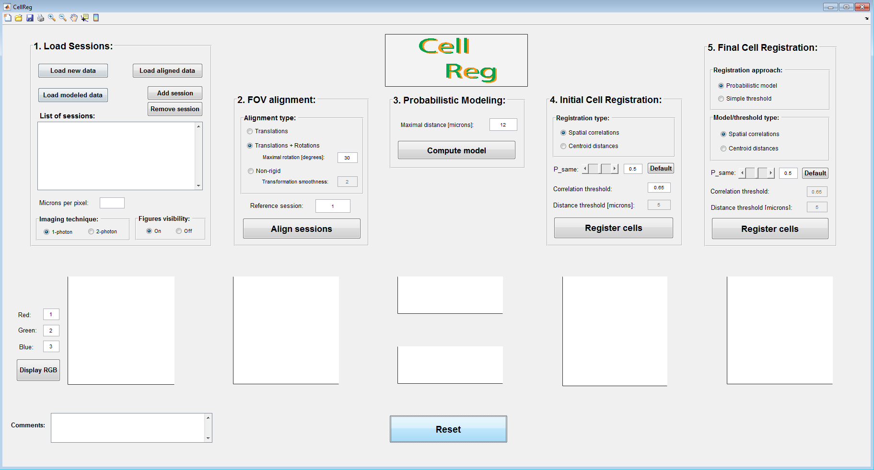The cell registration procedure is divided into five main steps:

1. Loading the data
2. Image alignment
3. Probabilistic modeling of the data
4. Initial cell registration
5. Final cell registration

In each step one or more figures will be plotted and saved in a designated folder. At the end of each step a message will appear reporting that the step is complete.

*\* If you prefer that the figures will not pop out automatically you can change the figures visibility radio button to ‘off’. In any case the figures are saved automatically.*

**Structure of the inputs:**

Prior to cell registration, organize your data according to the required format. The spatial footprints of cellular activity (ROIs) must be provided for each session separately.

The matrix of the spatial footprints is of size NxMxK, where N is the number of neurons, M is the number of pixels in the y axis and K is the number of pixels in the x axis. Each entry in the matrix is equal to the corresponding pixel's value which represents its contribution to the overall cell's fluorescence.

When organizing your data you can use one of two options:

1. Put all the .mat files with the detected spatial footprints of cellular activity in a single folder and press the **load new data** button. The names of the files should allow their automatic ordering (e.g., ‘spatial_footprints_01’, ‘spatial_footprints_02’,…, ‘spatial_footprints_xx’)
2. Put the file of each session in a different folder.

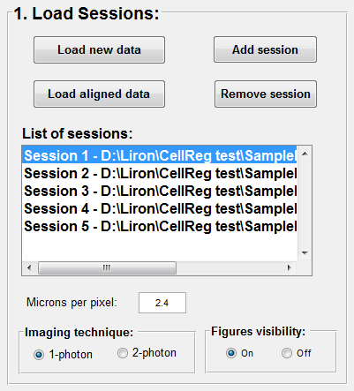**Step 1 – Loading the data:**

* 1. On the top left corner of the GUI press the **load new data** button.
  2. A message box will appear asking you to choose the files with the spatial footprints from all the sessions. Please select the folder “**SampleData**”.
  3. A message box will appear asking for the pixel size in µm. Please insert ‘**2.3**’ in the micron/pixel field and press enter.
  4. A message box will appear asking you to choose the folder in which to save the cell registration results. Please create a new folder for this purpose and select it.

*\* For imaging data recorded with 2-photon microscopy change the relevant radio button before the next stage. For such data only the centroid distances model will be computed.*

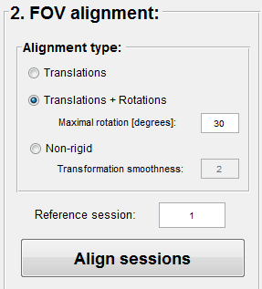**Step 2 – FOV alignment:**

For this sample data set there is no need for rotational correction across sessions. Choose the “**Translations + Rotations**” transformation type (if only translations is required it significantly shortens the runtime), reference session “**1**” (different reference is also ok), and press the “**Align sessions**” button.

There is also an option for non-rigid transformation in cases that other types of FOV distortions are observed (e.g., warping, scaling, and shear).

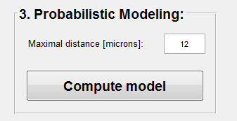**Step 3 – Probabilistic modeling of the data:**

Choose maximal distance “**12**” and press the “**Compute model**” button.

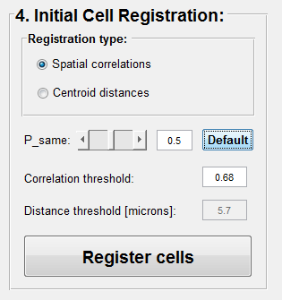**Step 4 – Initial cell registration:**

Choose the “**Spatial correlation**” registration type and press the “**Register cells**” button. The spatial correlation threshold is automatically set to suit the specific data set.

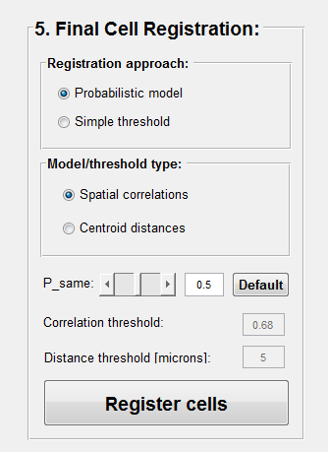**Step 5 – Final cell registration:**

Choose the “**Probabilistic model**” approach, the “**Spatial correlations**” probability model, Psame threshold “**0.5**”, and press the “**Register cells**” button.

You have just finished the cell registration procedure**!**

**Results and outputs:**

The final cell registration results will be saved in the registration results folder in the file “**cellRegistered_<date>_<time>.m**”. This is a MATLAB structure which includes several matrices with information regarding N registered cells from M imaging sessions:

1. “cell_to_index_map” – A matrix of size NxM, with the mapping of each registered cell to the indices in each registered session.
2. “cell_scores” – A vector of size N with the registration qualities (ranges 0-1) for all registered cells. Also included a decomposition of the scores to true positive scores, true negative scores, and exclusivity scores.
3. “is_cell_in_overlapping_FOV” – A logical vector of size N where the value is 1 if the cell was within the imaged FOV in all sessions and 0 otherwise.
4. “registered_cells_centroids” – A matrix of size Nx2 with the average centroid locations of all registered cells.
5. “centroid_locations_corrected” – A cell of size M. In each cell there is a matrix of size Nix2; with the transformed centroid locations of all registered cells. Ni is the number of detected cells in the ith session.
6. “spatial_footprints_corrected” – A cell of size M. In each cell there is a matrix of size NixMxK; with the aligned spatial footprints of all registered cells. Ni is the number of detected cells in the ith session.

A log file with all the relevant information regarding the data, registration configuration, and a summary of the registration results is saved automatically.